Experiment-8
Name: Mithun Raj.D Rollno:240701315

Create storyboards to represent the user flow for your application using Balsamiq

Aim
To design and prototype a user-friendly wireframe for a Doctor Appointment Booking Application using Balsamiq, representing the complete user workflow in a single combined view.

Tools Used
- Balsamiq (Wireframing Tool)

Description
This project presents a doctor appointment booking application interface designed using Balsamiq. Similar to the cinema booking system, all major steps of the appointment process are combined into a unified storyboard view.
The wireframe includes doctor browsing, doctor details, slot selection, and payment & confirmation. This helps in clearly visualizing the complete user journey from selecting a doctor to confirming an appointment.

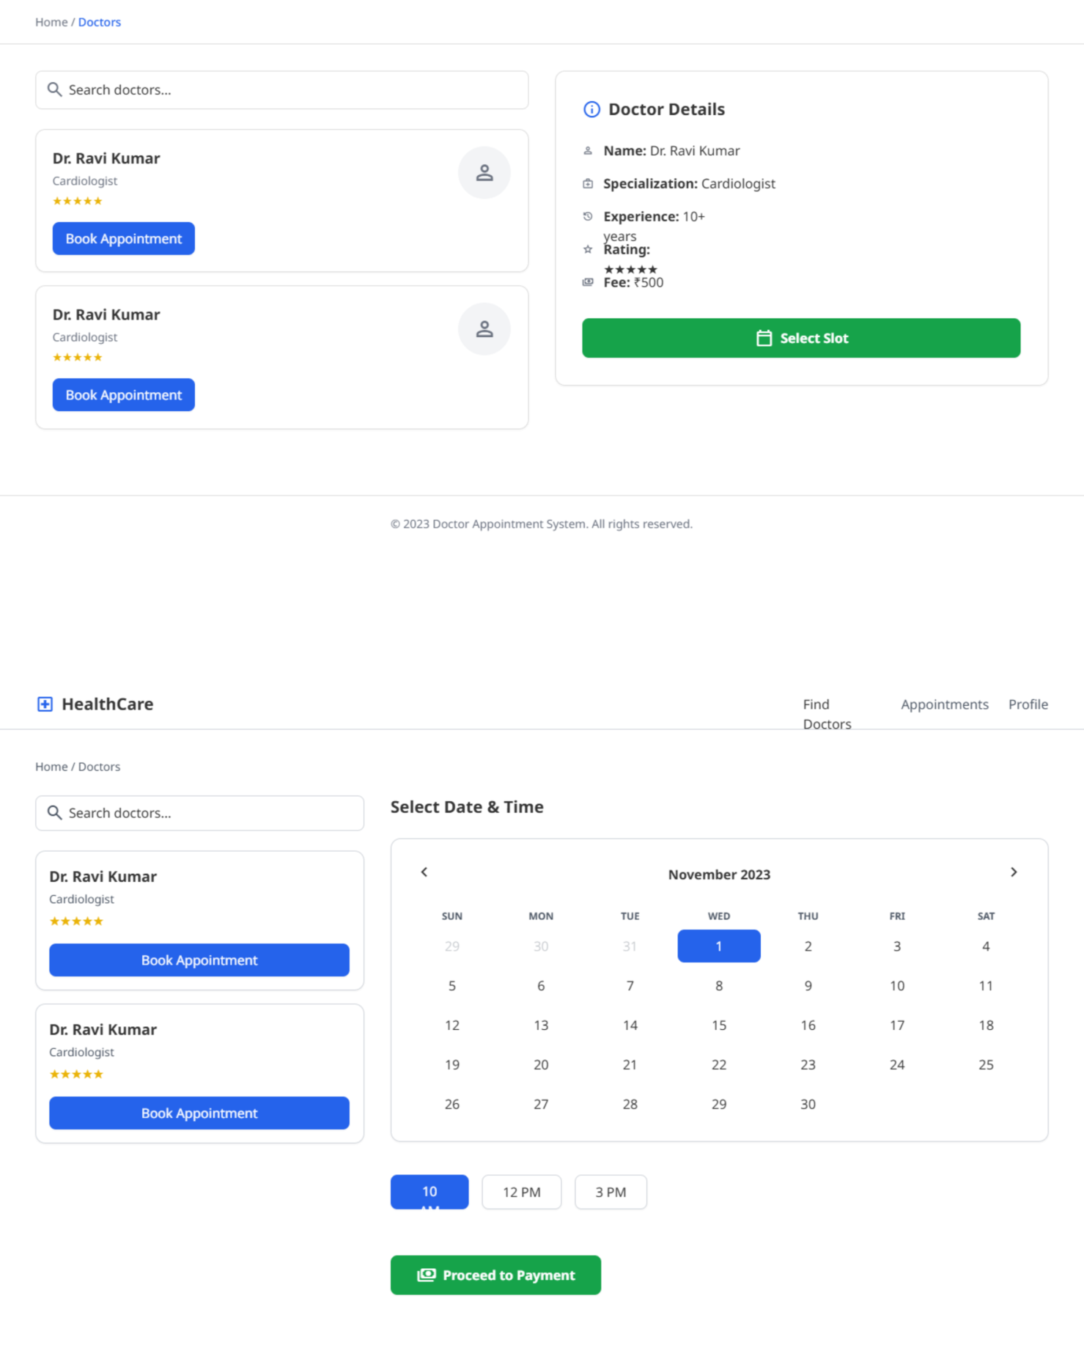
Wireframe

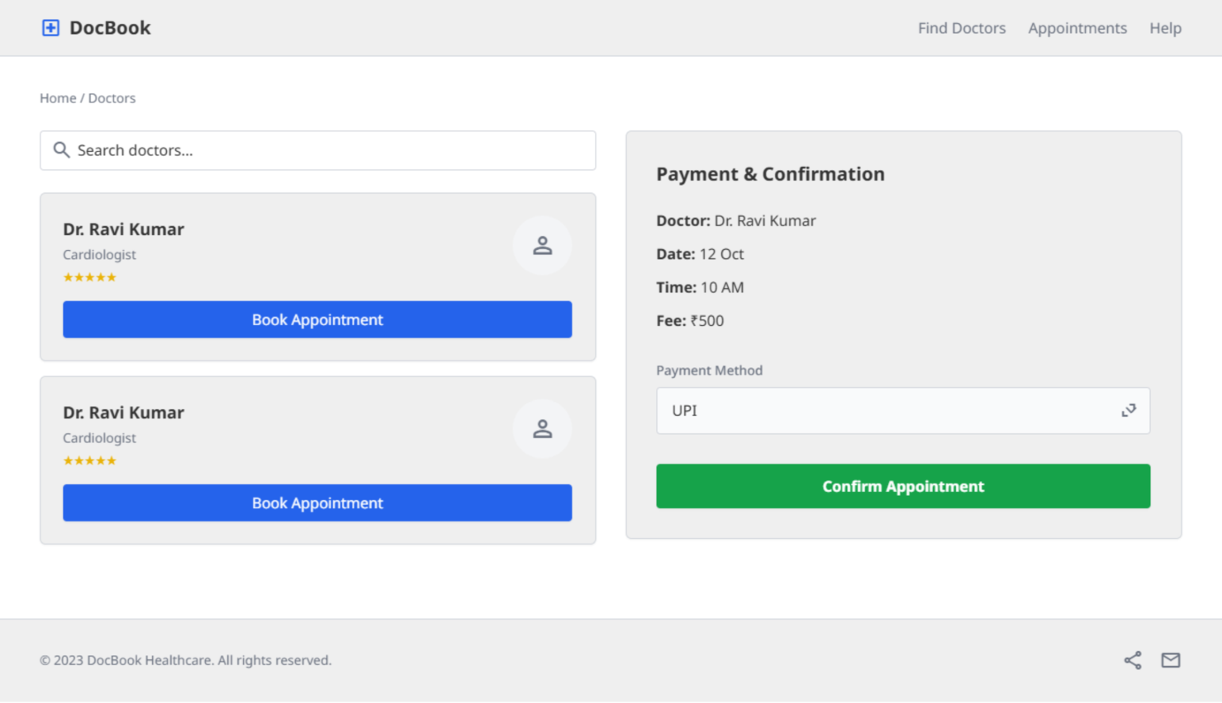

Explanation of the Wireframe
The combined wireframe represents the full workflow of the doctor appointment booking application:

Home / Doctor Listing Section
  - Users can browse available doctors
  - A search bar allows users to quickly find doctors by name or specialization
  - Each doctor is displayed in a card format with:
  - Name
  - Specialization
  - Rating
  - Each card contains a “Book Appointment” button

Doctor Details Section
  - Displays detailed information about the selected doctor:
    - Name
    - Specialization
    - Experience
    - Rating
    - Consultation fee
  - Provides a clear overview for decision-making
  - Includes a “Select Slot” button to proceed

Slot Selection Section
  - Displays a calendar interface for date selection
  - Users can choose available time slots (e.g., 10 AM, 12 PM, 3 PM)
  - Selected slot is highlighted for clarity
  - Includes a “Proceed to Payment” button

Payment & Confirmation Section
  - Displays appointment summary including:
    - Doctor name
    - Date and time
    - Consultation fee
  - Provides payment options such as:
    - UPI
    - Card
    - Wallet
  - Final confirmation is done using “Confirm Appointment” button
  - Displays confirmation message after successful booking

Flow of Events
- User searches or browses available doctors
- Selects a doctor from the list
- Views doctor details
- Selects date and time slot
- Proceeds to payment
- Confirms appointment and receives confirmation

Conclusion
The combined wireframe effectively represents the entire doctor appointment booking workflow in a single view. It improves understanding of user interactions across different stages and helps in designing a smooth and efficient healthcare booking system.

Wireframe Link - https://balsamiq.cloud/sjgkso1/pq1f5ow

Seat Selection Section
  - Shows seat layout with available and booked seats
  - Users can select seats and view total price
  - Option to proceed to payment

Payment & Confirmation Section
  - Displays booking summary and total amount
  - Provides payment options (UPI, Card, Wallet)
  - Booking is confirmed with a ticket preview

Conclusion
The combined wireframe effectively represents the entire movie ticket booking process in a single view. It helps in understanding the flow of the application and user interactions across different stages, making it easier to design and develop a user-friendly cinema booking system.

